Scenario 6 : 4 tables outer joined

In situations with 3 or more tabels outer-joined, the order of joining becomes crucial. Let's take a look at this simple example:

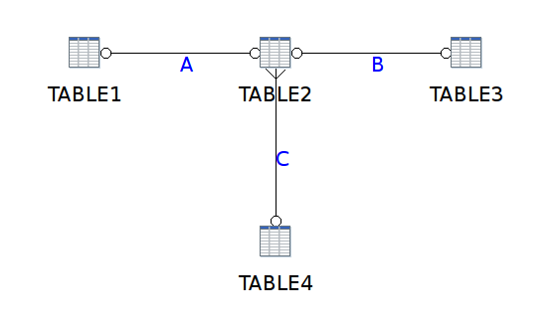

What we want to see is that the 4 entries (1,2,3 and 4) in Table4 are taken and outer joined with the information in the other 2 tables. The other 3 tables contain less records.

So we defined the relationships, but now the order of execution makes a huge difference: First we want to execute relationship A, then B and then C.

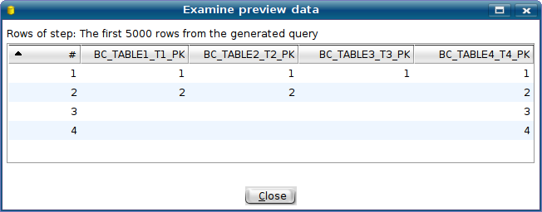

The query generated is this one:

SELECT DISTINCT
TABLE1.PRIMARYKEY AS COL0
,TABLE2.PRIMARYKEY AS COL1
,TABLE3.PRIMARYKEY AS COL2
,TABLE4.PRIMARYKEY AS COL3

FROM TABLE4 LEFT OUTER JOIN
(
TABLE3 FULL OUTER JOIN
(
TABLE1 FULL OUTER JOIN TABLE2
ON ( TABLE1.PRIMARYKEY = TABLE2.FOREIGNKEY )
)
ON ( TABLE2.PRIMARYKEY = TABLE3.FOREIGNKEY )
)
ON ( TABLE2.FOREIGNKEY = TABLE4.PRIMARYKEY )

ORDER BY
TABLE4.PRIMARYKEY

As you can see, a nested join syntax is generated that forces an execution order:
- the red inner part first : join Table1 and Table 2 = A
- then the middle blue part : join Table 3 and A = B
- and finally the rest of the join : join Table 4 with B = Result

Other execution orders would be just as valid depending on the business context in which they are used. However, an other execution order in general yields a different result.

As such, to allow the business model designers to make sure that user selections are executed in a particular way, a “Join Order Key” is added in the Relationship dialog:

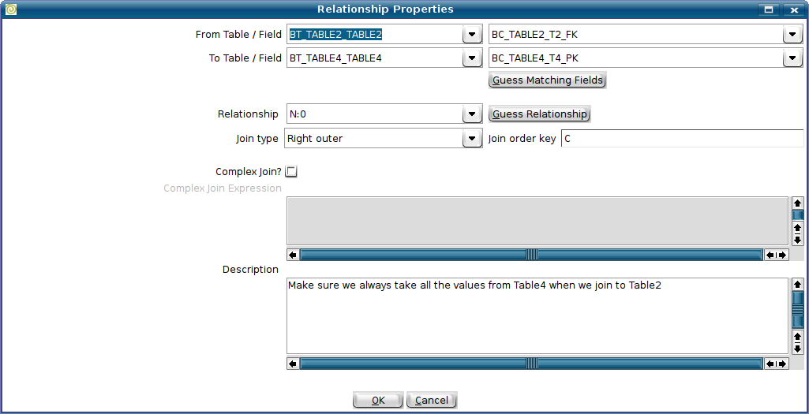

Obviously, the join order key is ONLY relevant in situations where outer joins are deployed in business models. To make the importance of the execution order apparent, we display this information in the graphical view of the model. (see above)

